**Personal Portfolio**

Student Name: Jeremy (TianYing Zhou)

Student Number: n8955557

Group: 038

1. Developing the functions and User Interface
2. Establish and improve the user stories.
3. Prototyping and developing the user experience
4. Doing some user acceptance testing with your client to ensure that the completed stories meet their expectations
5. Finishing the release plan
6. **Developing the functions and User Interface:**

This is my first three weeks of work. As the development team, we need to create the functions and the interface of our application. Our case is property management. So we need to be able to easily list all the housing information for this application. And I meet the client team. First I asked the client team what kind of webpage they would like to see. They told me that need clear and concise. Then I let them as the user, they told me they would like to:

a.see the list of the houses on the website.

b. search the houses, (put the sub, how many room you want,etc.)

c.select the house and show any other details of the houses.

d.Some recommendation of the houses.

e.website looks like friendly.

d.Something broken in the house should be marked.

f.The user can talk to the staffs some questions on the website.

And as a staff or manager, they would like to:

a.requite the questions from the users.

b.see the time of Inspections of the house.

c.See the contact functions of all the users.

Then I combine these things to complete our menu. However, the user interface has encountered challenges. Because we are all IS students, even if the re-designed gorgeous, we cannot show it out, so we decided to use the most simple interface to show up all of our functions.

1. **Establish and improve the user stories:**

At week 4, I meted with development team to review the current set of User Stories. First I started with the design of the webpage, and then began to design features; I designed different functions from different roles, such as managers, customers, employees, and David himself. Also i make the story have 4 different styles like Must Have, Should Have, Will Have and won’t have. Team members have also given me the stories they collect. Then I made the whole stories card as bellow:

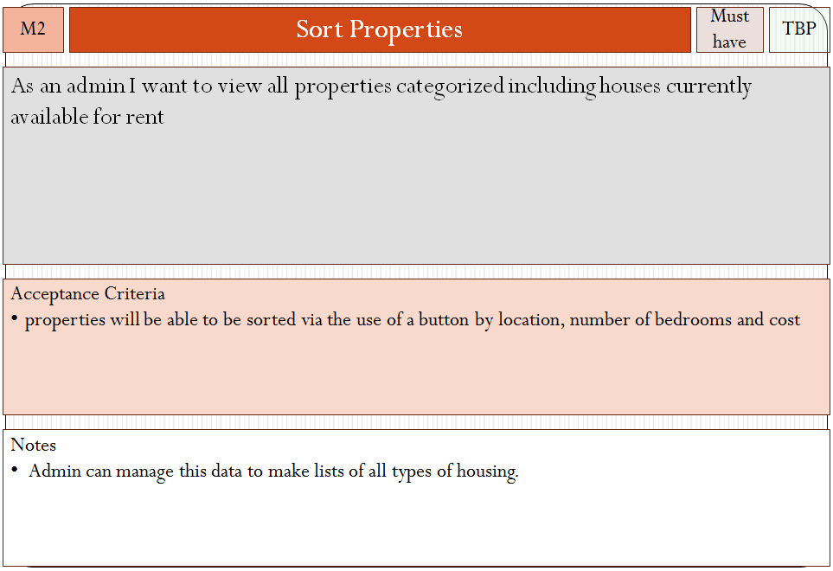

1. **Prototyping and developing the user experience:**

We intend to use VB to design user interface. We will make a very simple interface, but will have different functions. We have a database, which is the user's registration information, basically every user will have their own different levels, by changing the user level in database, to allow different users access to different functions.

Generally speaking, I have learned that the user experience substantially less attractive gathered at the interface. This is what we cannot change; because we are all IS students.

There are also some people think that we can make the temporary user can enter the system. I think this is a good proposal, and I propose to our team an idea. That is a temporary user can browse information about the house, but if you want to contact the staff, it must be registered as a formal member, because we have to guarantee the authenticity of the information. We will improve our application by using the user experience.

1. **Doing some user acceptance testing with your client to ensure that the completed stories meet their expectations**

I allow customers to do some testing, and let them d give me some advice through my stories card. They think we accomplished in accordance with the requirements of this program. Users can find the corresponding housing information. And you can contact the staff. They can search the houses, select the house and show any other details of the houses. If something was broken, it should be marked at the application.

If they are the stuffs, they can require the questions from the users as soon as possible. Stuffs can see the time of Inspections of the house and the contact functions of all the users.

1. **Finishing the release plan and sprint plan:**

When we finished the works as above, then we started to improve the release plan and sprint plan.

In the sprint I, we are trying to do three user stories which are **View Properties, Staff Profile and Contact Information.**

**In View Properties:** Create list view

Create test case

Ability to retrieve results via search Total : 32h

**In Staff Profile:** Create contact page

List staff members

Display staff pictures Total :16h

**In Contact Information:**

Attribute Homeowner Details to a house (Staff Access)

Attribute tenant details to a lease (homeowner + staff) Total: 4h

And the release plan is like bellow:

|  |  |  |
| --- | --- | --- |
| Story ID | Story Title | Story Points |
| 4 | Staff Contact Information | 2 |
| 5 | Tenant Contact Information | 2 |
| 5 | Homeowner Contact Information | 2 |
| 4 | Staff Picture | 2 |
|  | Story Point Sub-Total: | 8 |

|  |  |  |
| --- | --- | --- |
| Story ID | Story Title | Story Points |
| 2 | View Properties | 4 |
| 9 | View Property Pictures | 2 |
| 8 | Clear Interface | 1 |
|  | Story Point Sub-Total: | 7 |